Jenkins Assignment 5
Two EC2 launched and installed JAVA and tomcat on both Machines.
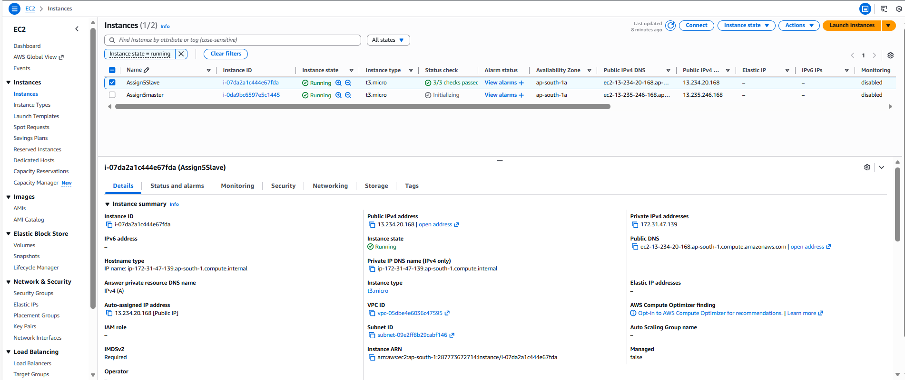

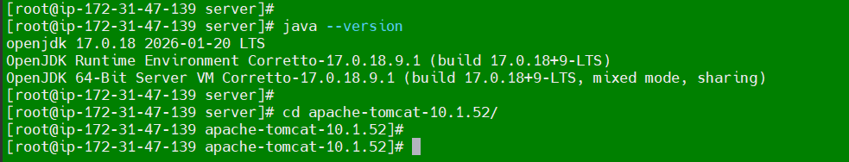

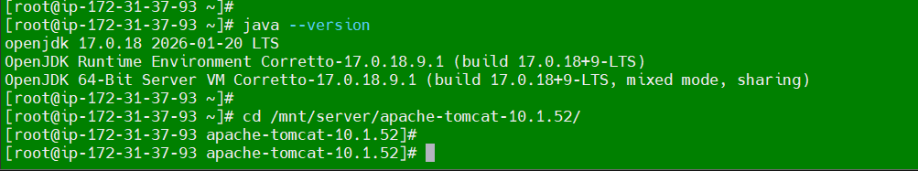

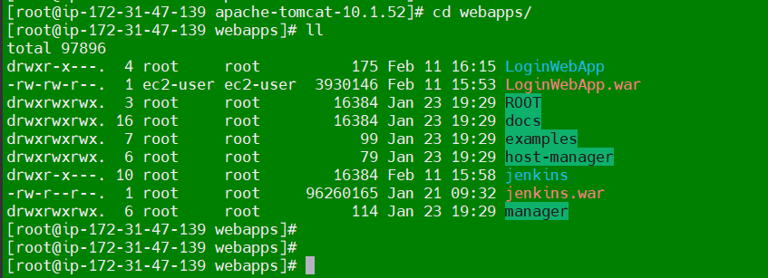
Downloaded from master by using maven.
Copied to S3 bucket

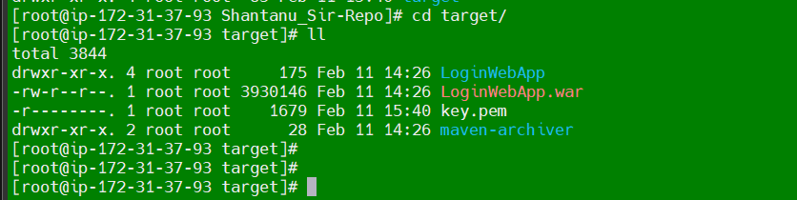
Copied loginWebApp.war on S3 bucket.
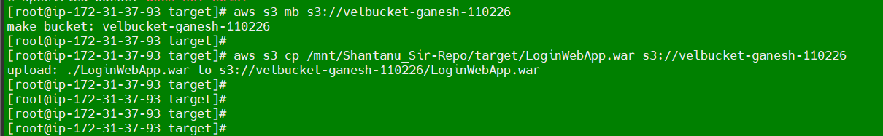

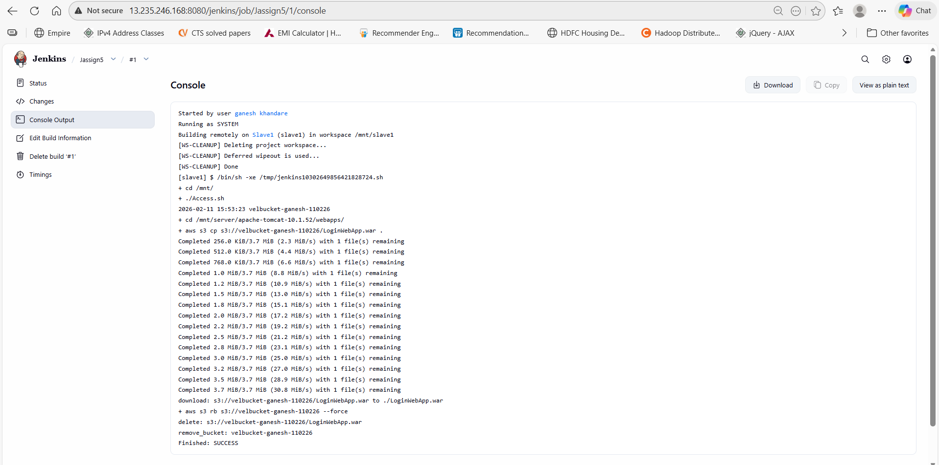

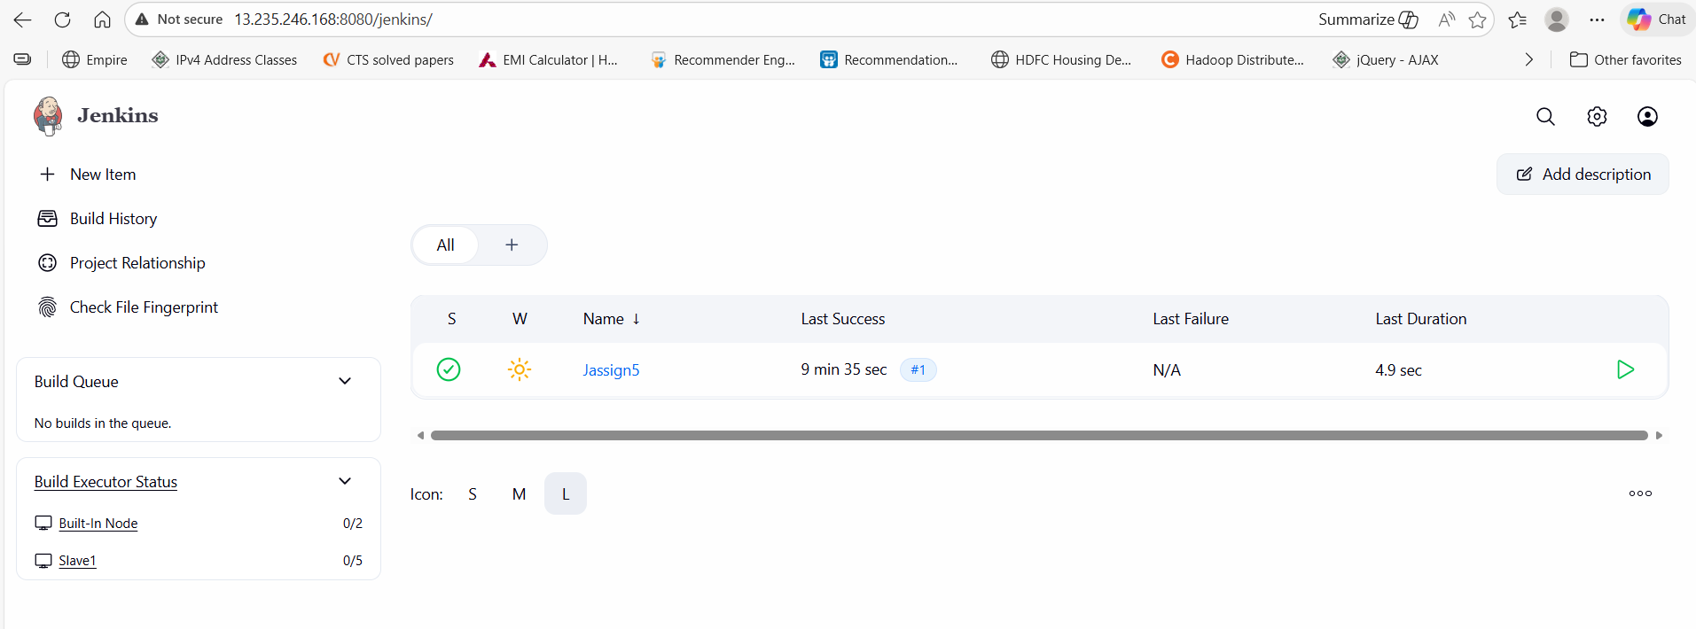
Copied LoginWebApp.war from S3 Bucket to Jenkins slave.
Post deployment removed the bucket.
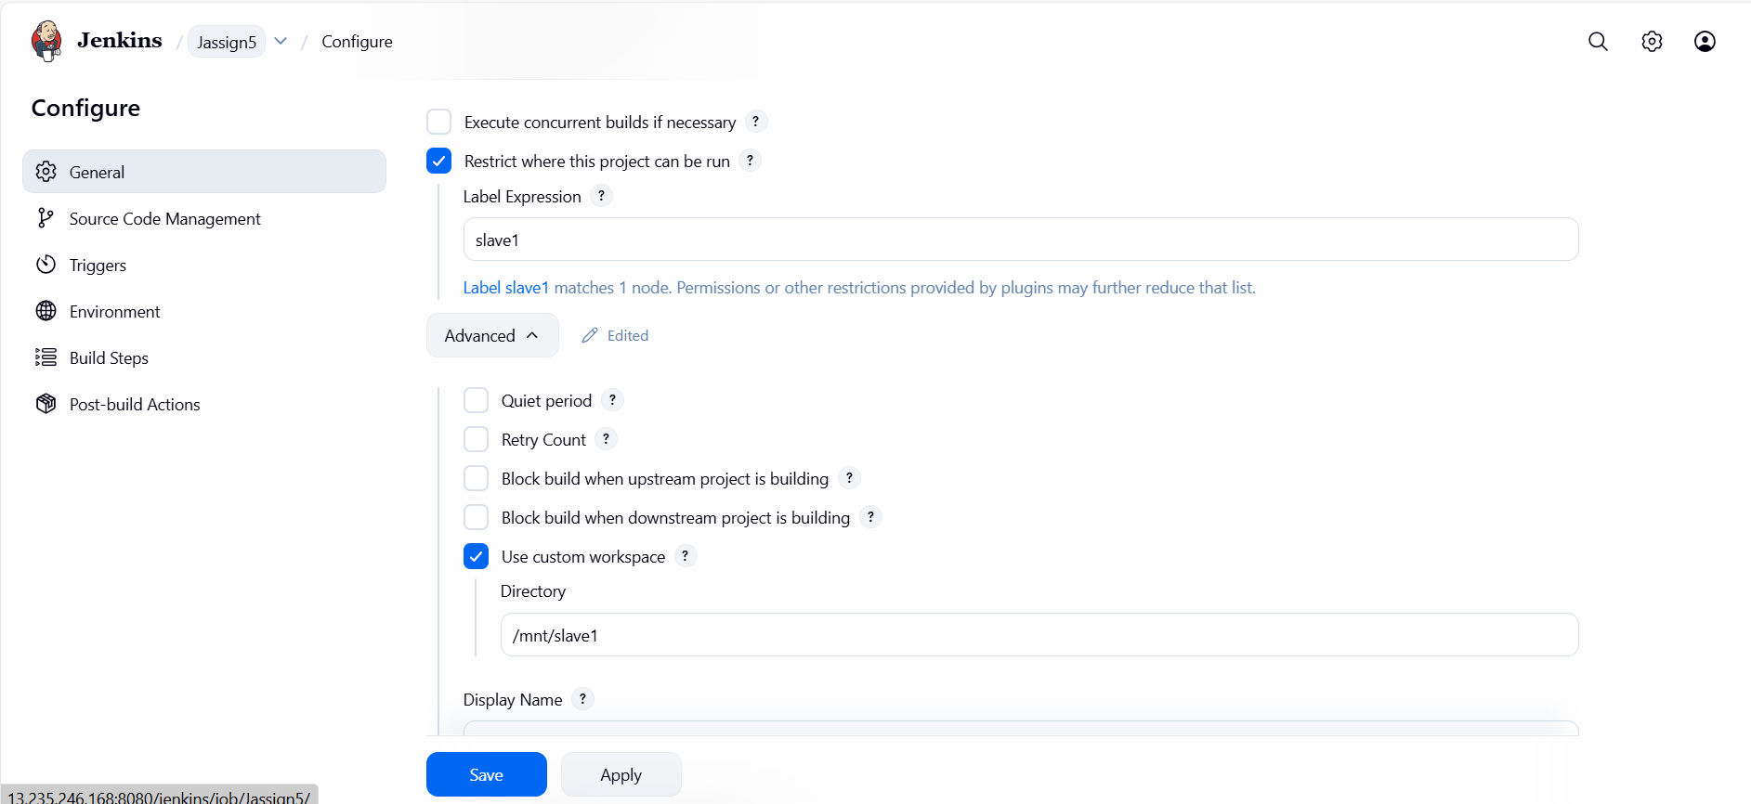
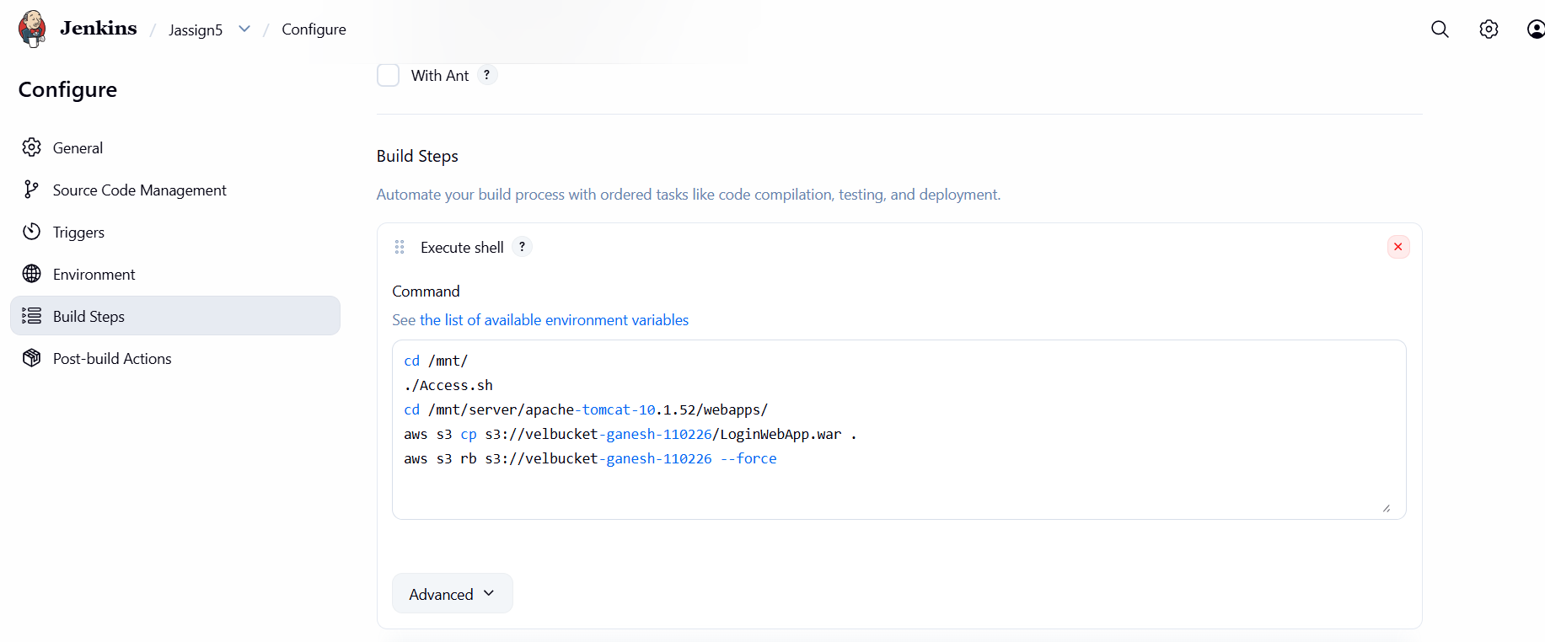s
Application working
